New Pet Intake Form

|  |  |  |  |
| --- | --- | --- | --- |
| Approved By: | Bianca Zenere, Rachel Shaw | Effective Date: | 11/16/2022 |
| Approval Date: | 11/16/2022 | Revised Date: | 12/21/2022 |
| Procedure Location: | Operations > Daycare | Number of Pages: | 6 |

Purpose

* To outline the proper steps to review Pet Intake Questions for a new pet.

Audience

* Center Manager (CM), Assistant Manager (AM), Customer Service Representative (CSR), Guest Service Specialist (GSS)

General Information

* If your center is not on Gingr yet, you will use the in-store version of the [Pet Intake Form](https://destpet.sharepoint.com/:w:/r/_layouts/15/Doc.aspx?sourcedoc=%7B16316798-5658-48D0-ABBD-51ECEA0593A6%7D&file=Pet%20Intake%20Questionnaire.docx&action=default&mobileredirect=true&cid=2d99890f-be05-4565-9761-246bad52c447) for every new pet.
* Clients will be required to answer all Pet Intake questions when setting up a pet profile on Gingr.
* If a Guest Services Specialist is setting up the profile, they will ask all Pet Intake questions and use the [Pet Intake Talking Points](https://destpet.sharepoint.com/:w:/r/_layouts/15/Doc.aspx?sourcedoc=%7B867B0227-430B-4DC2-8003-121A5EBD0D88%7D&file=New%20Client%20Intake%20-%20Talking%20Points.docx&action=default&mobileredirect=true&cid=34eaaa57-fd5a-4f82-a3b5-a8d386db5db6).
* All Pet Intake Questions will appear on the pet’s profile on Gingr.
* Staff will be responsible for maintaining the answers on the pet’s profile on Gingr as they observe behaviors.
* At check-in for a Meet and Greet, the owner will be responsible to stay and confirm the completed questionnaire or stay and complete the in-store version of the [Pet Intake Form](https://destpet.sharepoint.com/:w:/r/_layouts/15/Doc.aspx?sourcedoc=%7B16316798-5658-48D0-ABBD-51ECEA0593A6%7D&file=Pet%20Intake%20Questionnaire.docx&action=default&mobileredirect=true&cid=2d99890f-be05-4565-9761-246bad52c447), which may take 5-10 minutes.
* If there are any red flags, it is up to the General Manager’s discretion to accept the pet for services.

Procedure

1. CSR must pull the **Reservation by Date** report to view all Meet and Greets each morning by completing the following steps:
   1. Hover over the Reports and more icon and select **Reports.**

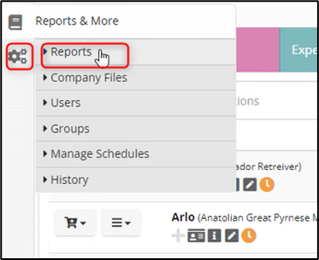

* 1. Type “reservations” into the Search Report box and select “**Reservations by Date**”.

* 1. Enter the date and select Meet and Greet reservation. Click **Generate Report**.

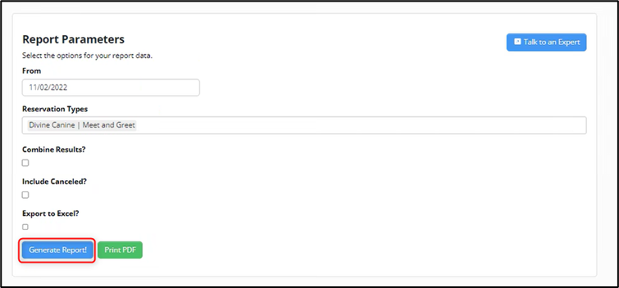

* 1. Scroll down to view Meet and Greets on that date.

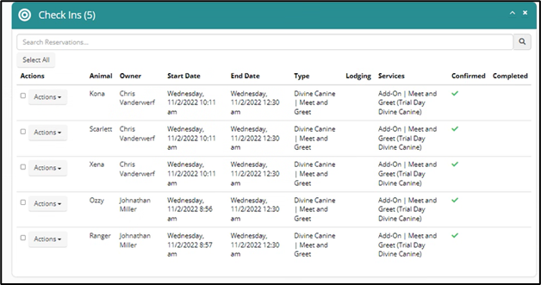

1. After pulling the report, the CSR must open each Meet and Greet pet’s profile and print the Pet Intake Questions.
   1. To print the questions, follow this procedure:
      1. Highlight the answered questions.
      2. Right Click.
      3. Select **Print.**
      4. This will only print the highlighted selection.

* 1. This process must be repeated with each Meet and Greet pet.

1. When the client arrives, the CSR will review all questions with the owner and make updates if needed.
2. If the owner did not complete the online questions, they must complete the [in-store version](https://destpet.sharepoint.com/:w:/r/_layouts/15/Doc.aspx?sourcedoc=%7B5B32D58E-3477-499D-A105-2E1FE51F551C%7D&file=Meet%20and%20Greet%20Intake%20Form.docx&action=default&mobileredirect=true).
3. Based on the owner’s response, the CSR will make any updates to the questions on the pet’s profile as needed.
   1. To edit the questions, the CSR will complete the following steps:
      1. Select the pet’s profile.
      2. Click the pencil icon and select edit animal.

* + 1. Scroll down to the behavioral questions section.

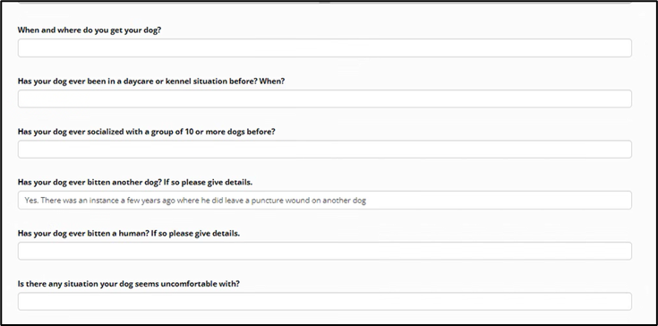

* + 1. Enter the current answers for each question.
    2. Scroll to the bottom and select **Save**.

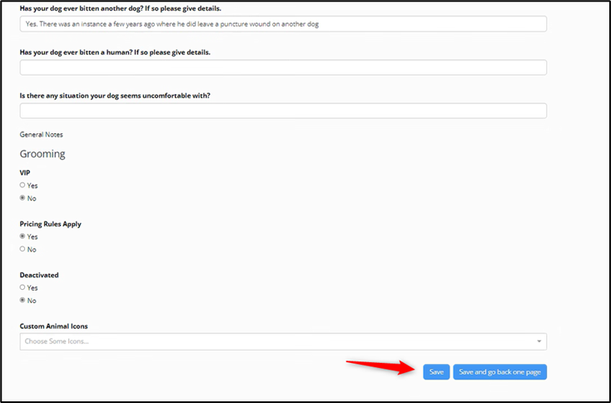

1. Return to the pet’s profile and review all questions to confirm the information listed is correct.
2. Once all information is correct, CSR will add icons for any red flags.
   * 1. Select the pet’s profile.
     2. Select the **+** symbol below Animal Icons.

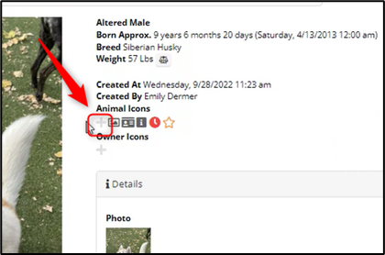

* + 1. Add appropriate icons.

1. CSR is to highlight any important answers on the Meet & Greet Intake Form questions sheet and give the document to the kennel supervisor or staff member doing Meets & Greets for that day.

References

* [New Pet Intake Form](https://destpet.sharepoint.com/:w:/r/_layouts/15/Doc.aspx?sourcedoc=%7B16316798-5658-48D0-ABBD-51ECEA0593A6%7D&file=Pet%20Intake%20Questionnaire.docx&action=default&mobileredirect=true&cid=2d99890f-be05-4565-9761-246bad52c447)

